

CMPE 272 - Enterprise Software Platform

| Professor Name: | Prof. Andrew Bond |
| --- | --- |
| Team: | Optimus |
| Team Members: | * Aishwarya Ravi * Ramya Mahesh * Shruthi Srinivasan * Satish Kathiriya (Team lead) |

HW #1 - Ansible

**Description:**

* Deploy three (3) Virtual Machines
* Configure Ansible server on VM 1 to deploy a webserver to VM2 and VM3 on port 8080 that displays the message: “Hello World from SJSU”
* Include in the Ansible playbook, plays to deploy and un-deploy all the webserver resources
* Due 9/12 (Sunday) at 11:59PM
* Submit a Word document via Canvas, with screenshots showing your work, and all ansible code/scripts via github

**Scope:** This document provides details on

* Creation of 3 virtual machines on AWS (Amazon Web Service) EC2 instances (1 Master and 2 client).
* Installation of Ansible on Master virtual machine
* startserver.yml: Creation of a playbook file to start appserver and bring it up a port 8080.
* stopserver.yml: Creation of a playbook file to stop appserver.

**Basic Requirements:**

* AWS account
* A Linux, windows or Mac computer

1. **Install Ansible on Master and python in client1 and client2 machine**
2. **Create Three EC2 AWS instances:**
3. Login to <https://console.aws.amazon.com>
4. Select the Instance EC2 instance type as “t2.micro”
5. Click on “Review and launch” button.
6. Configure Instances details by providing a few of the basic details like:

Number of the instances to be created: 3

Configure Security Groups→ add ‘HTTP’ in Type tab

1. **Connect EC2 via Putty:**
2. chmod 400 mykey.pem(Ubuntu.pem key generated while creating EC2 instance)
3. Put Host name as public IP address of ec2 instance

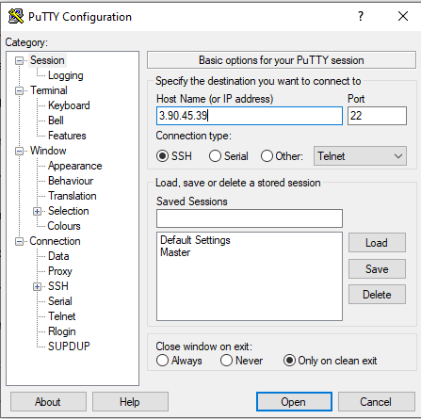

1. In Auth add Ubuntu.pem generated in step 1

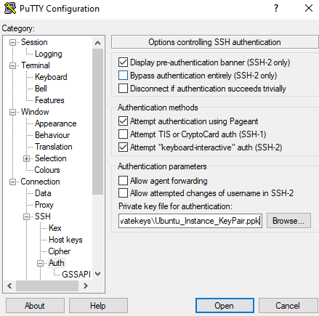

1. Add Ubuntu as username:

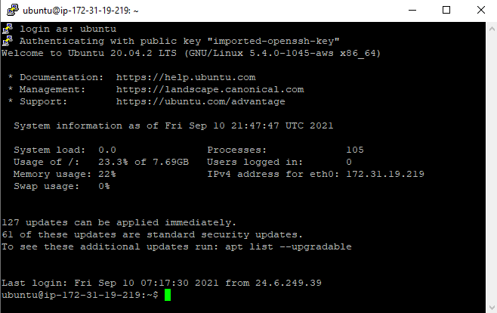

1. Install Ansible in Master with following command :

$ sudo apt update

$ sudo apt install software-properties-common

$ sudo add-apt-repository --yes --update ppa:ansible/ansible

$ sudo apt update

$ sudo apt install ansible

1. Install Python in client machine:

$ sudo apt update

$ sudo apt install python

1. **Configure keyless SSH access to Ansible Host machine**
2. In master server add IP address of client machine in “/etc/ansible/host” file

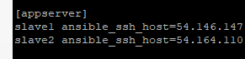

1. In master go to ~/.ssh and type "ssh-keygen"
2. This will create unique key in file "id_rds.pub"



1. Put this unique key from master server to the client machine in " /home/ubuntu/.ssh/authorized_keys” file
2. From master server check the SSH connectivity with all the client machine.

“ansible -m ping all”

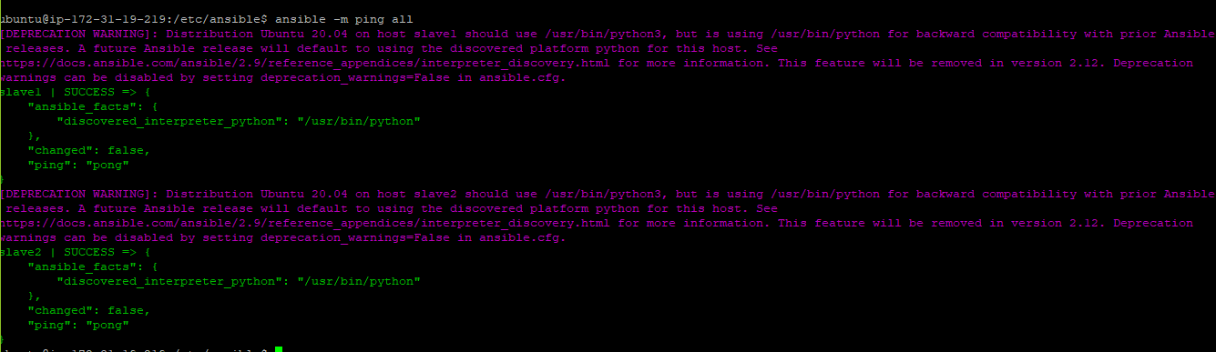

1. **Setting up Ansible host, yaml file and testing the connection** 
   1. Copy the StartServer.yml, StopServer.yml and index.html in one folder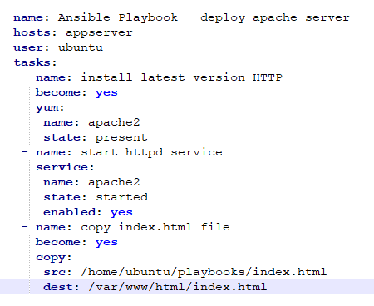

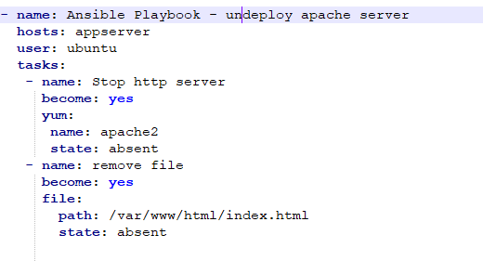

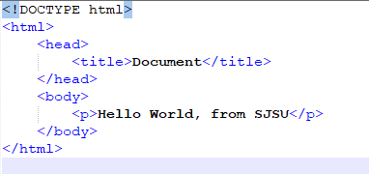

* 1. Run playbook by command “ansible-playbook <YML FILE NAME>”
  2. Start server : “ansible-playbook StartServer.yml

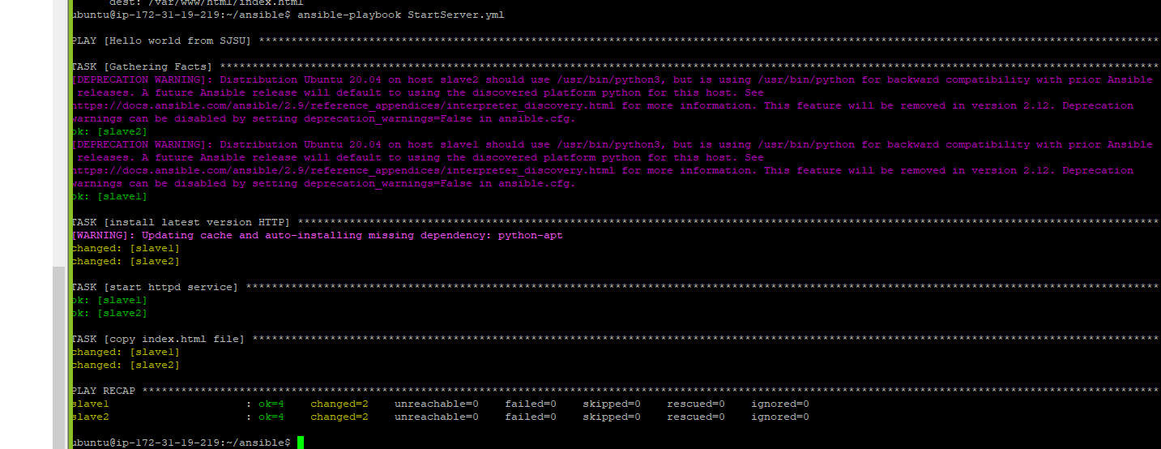

Start client 1:

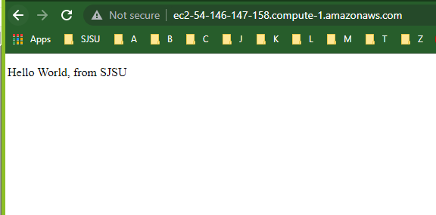

Start client 2:

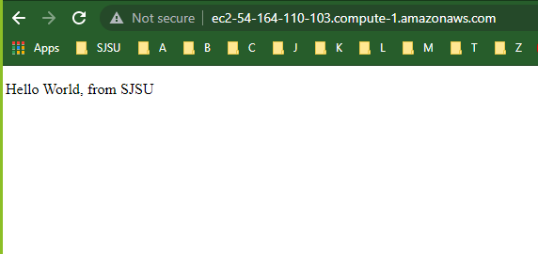

* 1. Stop Server : “ansible-playbook StopServer.yml

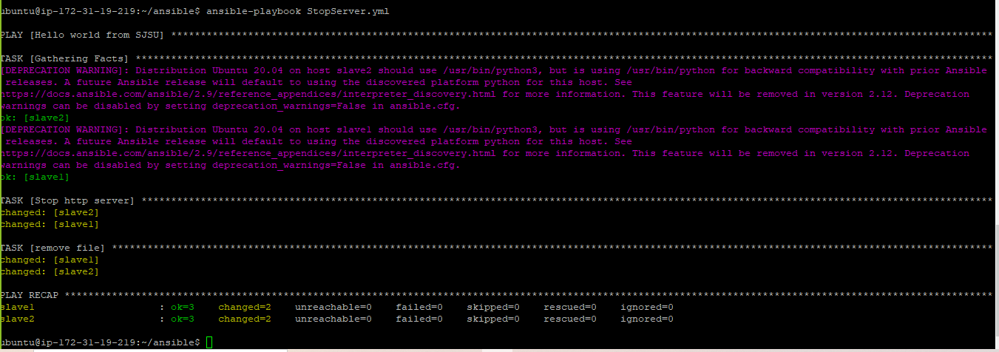

Stop client 1:

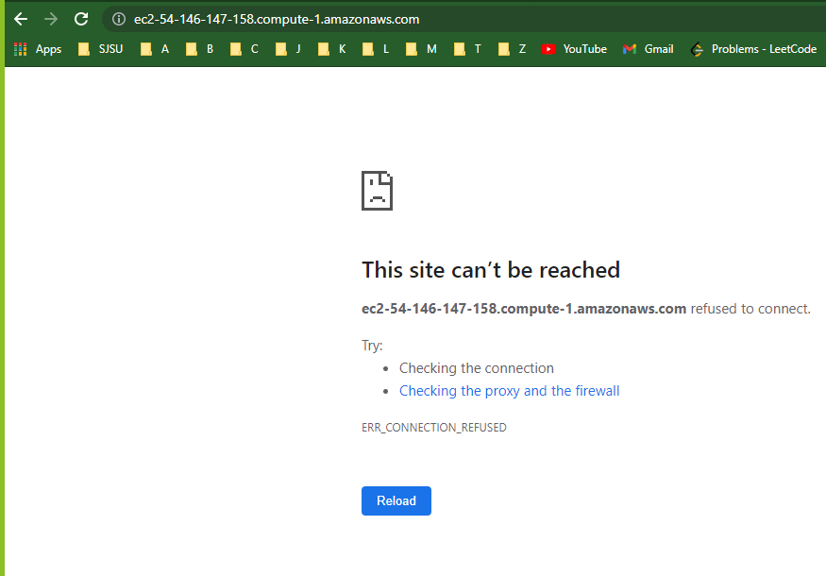

Stop client 2:

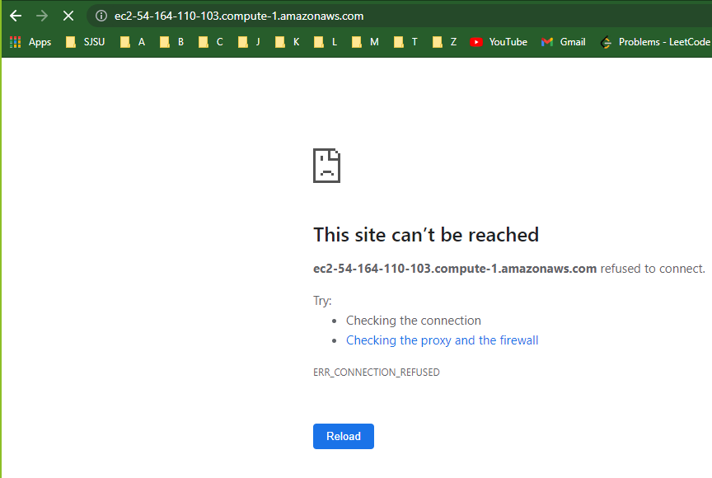

**Github Repository:** <https://github.com/satishkkk/LearnAnsible>

**Reference:**

<https://docs.ansible.com/>

<https://docs.ansible.com/ansible/latest/installation_guide/intro_installation.html>

<https://www.youtube.com/watch?v=Km3BCQnV6sw>

<https://codingbee.net/ansible/ansible-a-hello-world-playbook>